**Zomato Restaurant Analytics Dashboard** 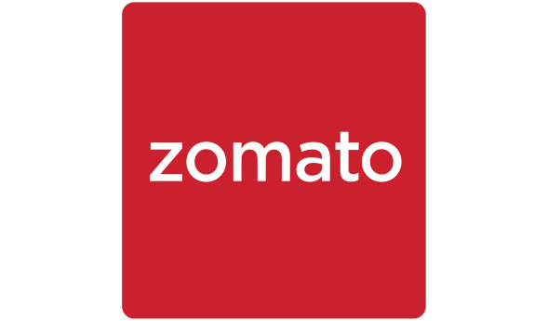

Prepared by Suchana Dey

MA Economics, Jadavpur university

**INTRODUCTION**

This report presents a comprehensive analysis of restaurant data sourced from Zomato, using interactive visualizations developed in Power BI. The primary objective is to derive key business insights regarding restaurant operations, service offerings, pricing, customer ratings, and geographical distribution. The dashboard covers various dimensions such as delivery and booking availability, pricing range, cuisine popularity, top-rated establishments, and regional spread of restaurants.  
  
This report is intended to support decision-making for stakeholders, including Zomato’s strategic team, restaurant partners, and policy makers. It emphasizes patterns in customer preferences, operational coverage, and service quality that can guide improvements, marketing strategies, and future expansion plans.

**Zomato Restaurant Analytics Dashboard**

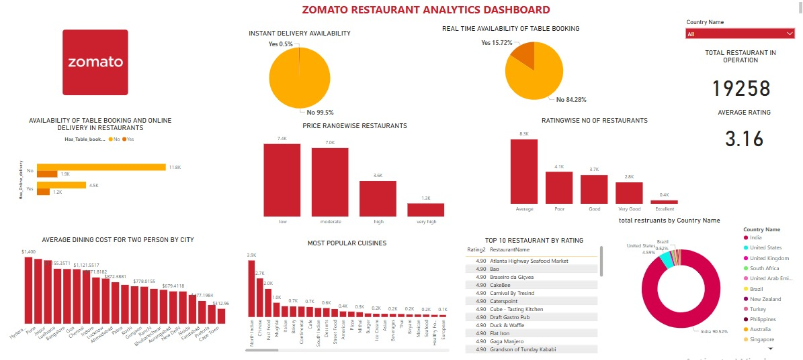Tabular Interpretation

|  |  |
| --- | --- |
| Visual | Interpretation |
| Instant Delivery Availability | Only 0.5% of restaurants offer instant delivery, while 99.5% do not, suggesting this service is highly limited. |
| Real-Time Table Booking Availability | Only 15.72% of restaurants allow real-time table booking; 84.28% do not, indicating a gap in real-time reservation infrastructure. |
| Availability of Table Booking and Online Delivery | Majority of restaurants (11.8k) do not offer table booking or delivery. Only 1.2k offer both, showing limited digital convenience. |
| Price Rangewise Restaurants | Most restaurants fall into the low (7.4k) and moderate (7.0k) price ranges, indicating affordability is key for majority. |
| Rating-wise Number of Restaurants | Most restaurants are rated 'Average' (8.3k), followed by 'Poor' (4.1k). Very few (0.4k) are rated 'Excellent', highlighting quality issues. |
| Average Dining Cost for Two Persons by City | Highest average cost is in Houston ($1,400), followed by New York and London. Indicates significant cost variation across cities. |
| Most Popular Cuisines | Indian North is the most popular cuisine (3.9k), followed by Mughlai (2.7k) and Chinese (2.0k), reflecting diverse taste preferences. |
| Top 10 Restaurants by Rating | Top restaurants have consistent ratings of 4.90. Variety includes seafood, Asian, and continental cuisines. |
| Total Restaurants by Country | India dominates with 50.52% of restaurants. United States, Brazil, and others follow. Indicates Zomato’s strong presence in India. |
| Total Restaurants and Average Rating | There are 19,258 restaurants with an average rating of 3.16, showing a mid-range overall satisfaction. |

## **Performance Gaps and Opportunities for Enhancement**

### **1. Instant Delivery Services Are Rare (Only 0.5%)**

* **Insight**: Instant delivery is almost nonexistent.
* **Improvement**: Partner with high-demand urban restaurants to pilot instant delivery in selected cities.

### **2. Low Real-Time Table Booking Availability (15.72%)**

* **Insight**: Vast majority (84.28%) of restaurants don’t offer real-time booking.
* **Improvement**: Incentivize restaurants to enable real-time booking via Zomato’s tech integration tools.

### **3. Limited Online Services (Table Booking + Delivery)**

* **Insight**: Most restaurants (11.8k) don’t offer either table booking or delivery.
* **Improvement**: Zomato could run outreach or onboarding programs for traditional restaurants to join the digital platform fully.

**4. Restaurant Pricing Is Concentrated in Low & Moderate Segments**

* **Insight**: 75%+ restaurants fall under low or moderate prices.
* **Improvement**: Introduce curated premium experiences or loyalty tiers for higher-margin segments.

### **5. Average Customer Rating is Low (3.16)**

* **Insight**: The overall rating across 19,000+ restaurants is just above average.
* **Improvement**: Launch a quality improvement program with feedback tracking, hygiene training, and customer service workshops.

### **6. Poor and Average Ratings Dominate**

* **Insight**: 8.3k restaurants are rated average; 4.1k are poor.
* **Improvement**: Identify these restaurants and implement quality intervention strategies; offer incentives for consistent improvements.

### **7. Huge Variation in Dining Costs Across Cities**

* **Insight**: Cost for the two ranges from $400 to $1,400 depending on the city.
* **Improvement**: Customize marketing campaigns based on affordability index and average spend in each city.

### **8. Cuisine Preferences Are Skewed Toward a Few Types**

* **Insight**: Indian North, Mughlai, and Chinese dominate.
* **Improvement**: Explore underrepresented cuisines and promote diversity via food festivals, featured listings, or influencer marketing.

### **9. India Dominates Zomato's Market (50.52%)**

* **Insight**: Half of the restaurant base is in India.
* **Improvement**: Double down on India with hyperlocal personalization but explore new country expansion based on gaps (e.g., Southeast Asia, Africa).

### **10. Only a Few Restaurants Reach Top Rating (4.90)**

* **Insight**: All top-rated restaurants are clustered at the same rate.
* **Improvement**: Introduce a **rating + engagement score** system that highlights consistent performance over time, not just ratings.

**Zomato Restaurant Analytics Dashboard – India**

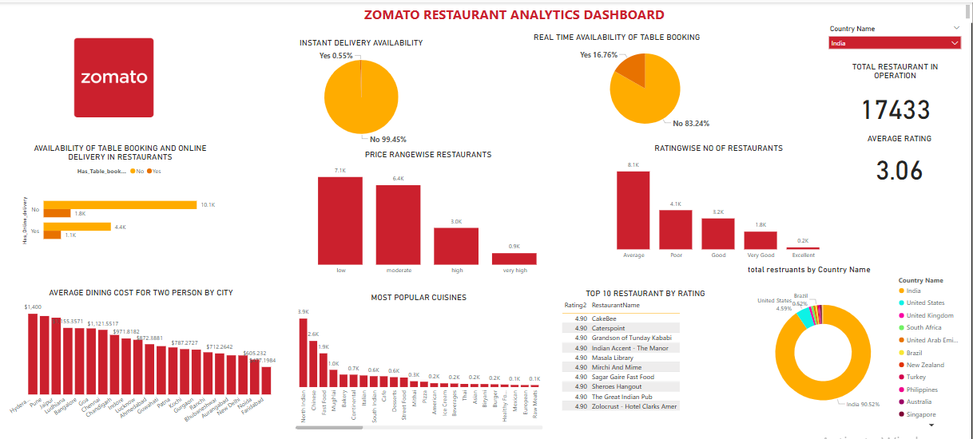**Actionable Insights**

**1. Instant Delivery Availability Remains Negligible**

* **Only 0.55%** of restaurants offer instant delivery.
* **Opportunity**: Expand instant delivery services in metros through strategic partnerships and high-frequency kitchen zones.

### **2. Low Real-Time Table Booking Availability**

* **Only 16.76%** of restaurants allow real-time bookings.
* **Gap**: Many restaurants still operate on walk-ins or offline reservations.
* **Improvement**: Incentivize adoption of digital reservation systems via Zomato Pro integrations.

### **3. Online Services Coverage is Limited**

* Out of **17,433** restaurants, **10.1k** do **not offer** table booking or delivery.
* Only **1.1k** offers both.
* **Improvement**: Launch a restaurant digitization program targeting small and mid-tier eateries, especially in Tier 2 and Tier 3 cities.

### **4. Restaurants Clustered in Lower Price Brackets**

* Majority in **low (7.1k)** and **moderate (6.4k)** price categories.
* High-end (3.0k) and very high (0.9k) are much fewer.
* **Improvement**: Introduce and promote premium dining experiences, curated offers, and exclusive chef menus to tap into aspirational spending.

### **5. Restaurant Ratings Skew Low**

* **Average rating: 3.06** — indicating mid-level customer satisfaction.
* **8.1k** rated "Average", only **0.2k** rated "Excellent".
* **Improvement**: Run a "Quality Boost Program" with hygiene audits, feedback training, and rewards for high-rated improvements.

### **6. Huge Variation in Dining Cost Across Citiess**

* Highest: Hyderabad ($1,400), Pune, Bengaluru, Mumbai also on higher side.
* Lowest: Patna ($603), Bhopal, Raipur.
* **Opportunity**: Geo-targeted offers and loyalty rewards can optimize customer retention in low-cost markets.

### **7. Cuisine Preferences are Strongly Indian**

* **Top 3**: North Indian (3.9k), Mughlai (2.6k), Fast Food (1.9k).
* Very low representation of international cuisines.
* **Improvement**: Encourage and spotlight diverse cuisines through food festivals, Zomato events, and culinary campaigns.

### **8. Top Rated Restaurants Consistently Score 4.90**

* Top names like **CakeBee, Masala Library, Indian Accent** hold 4.90 ratings.
* **Insight**: High-quality, well-managed places maintain consistency.
* **Improvement**: Use case studies from top performers to guide others on achieving excellence in service, ambiance, and menu design.

### **9. 🇮🇳 India is Zomato's Core Market (90.52%)**

* Out of total restaurants in the system, **over 90%** are Indian.
* **Strategic Priority**: This market deserves continued innovation, real-time feedback integration, and deeper consumer personalization.

## **Strategic Improvements for Zomato in the Indian Market**

### **1. Boost Instant Delivery Infrastructure**

* **Current Issue**: Only **0.55%** of restaurants offer instant delivery.
* **Action**: Launch pilot programs in metro cities (Delhi, Mumbai, Bengaluru) using cloud kitchens to enable <20-minute delivery, leveraging strategic kitchen locations and limited-menu optimization.

### **2. Digitize Restaurant Operations at Scale**

* **Current Issue**: 10.1k restaurants still lack both table booking and delivery features.
* **Action**:
  + Offer zero-cost onboarding for digital services.
  + Partner with **Point-of-Sale** (POS) providers like Petpooja, Posist and Rista to integrate booking/delivery tools.
  + Add digital enablement badges on Zomato profiles to promote participation.

### **3. Raise Rating Standards and Customer Experience**

* **Current Issue**: Majority ratings hover around 3.0, with very few “Excellent” performers.
* **Action**:
  + Introduce a “Restaurant Excellence Accelerator” to guide mid-rated restaurants on food quality, hygiene, and service improvements.
  + Gamify improvements with quarterly rewards and visibility boosts for ratings uplift.

### **4. Create a Balanced Price-Point Ecosystem**

* **Current Issue**: Skewed concentration in low-to-moderate price bands.
* **Action**:
  + Promote premium segments with influencer marketing, chef-led experiences, and loyalty-based dining rewards.
  + Introduce curated categories like “Affordable Luxury,” “Festive Dining,” etc.

### **5. Improve Booking Rate with Real-Time Table Integration**

* **Current Issue**: Only 16.76% restaurants provide table booking.
* **Action**:
  + Provide plug-and-play APIs for restaurants to auto-sync availability.
  + Offer fee discounts for Zomato Pro-exclusive bookings.

### **6. Drive Culinary Diversity**

* **Current Issue**: Indian cuisines dominate; global cuisine underrepresented.
* **Action**:
  + Run “World Food Month” campaigns to spotlight underrepresented cuisines (Korean, Greek, Ethiopian).
  + Provide ad credits to global cuisine restaurants for enhanced discovery.

### **7. Use Regional Pricing Insights to Optimize Offers**

* **Current Issue**: High-cost variance — from ₹603 (Patna) to ₹1,400 (Hyderabad).
* **Action**:
  + Geo-segment campaigns based on affordability index.
  + Design custom offers, discounts, and delivery fee waivers based on city-level cost thresholds.

### **8. Replicate Best Practices from Top-Rated Outlets**

* **Current Insight**: Top-rated restaurants score 4.90 consistently.
* **Action**:
  + Launch a “Zomato Academy” with behind-the-scenes stories, SOPs, and quality tips from top performers.
  + Match struggling outlets with mentors from high-rated ones.

**Zomato Restaurant Analytics Dashboard – South Africa**

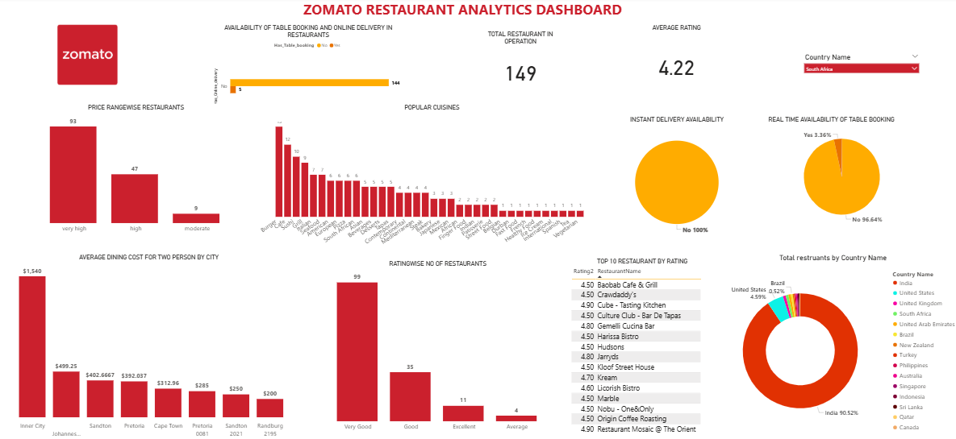**Actionable Insights**

### **1. Instant Delivery Availability Remains Non-Existent**

**Observation**: 0% of restaurants offer instant delivery.  
 **Opportunity**: Launch pilot “express zones” in high-density areas like Johannesburg and Cape Town using cloud kitchens or dark stores.

### **2. Real-Time Table Booking Almost Absent**

**Observation**: Only 3.36% of restaurants offer real-time booking.  
 **Gap**: 96% of venues still rely on offline reservations or walk-ins.  
 **Improvement**: Offer incentives such as “table booking fee waivers” and Zomato Pro partner benefits for adoption.

### **3. Online Services Coverage is Severely Lacking**

**Observation**: Out of 149 restaurants, only 5 offer both delivery and table booking.  
 **Improvement**: Deploy a “Restaurant Go-Digital” outreach campaign across Johannesburg, Pretoria, and Sandton, with simplified POS integrations and onboarding kits.

### **4. Price Category Heavily Skewed Toward Premium**

**Observation**: 93 restaurants fall in the **very high** price category. Only 9 are moderate.  
 **Improvement**: Encourage budget-friendly entrants with Zomato listing subsidies and student-city offers for more diverse price segmentation.

### **5. Ratings Concentrated in ‘Very Good’**

**Observation**: 66% of restaurants rated **Very Good**; only 11 labeled **Excellent**.  
 **Improvement**: Introduce customer-experience certifications and hygiene scorecards to elevate mid-tier performers.

### **6. Major Dining Cost Disparities Between Cities**

**Observation**:

* **Highest**: Inner City ($1,540)
* **Lowest**: Randburg ($200)  
   **Opportunity**: Deploy location-specific offers in higher-priced zones to drive frequency, and reward programs in lower-cost areas to boost loyalty.

### **7. Limited Cuisine Spread**

**Observation**: Popular cuisines include **Burger**, **Steak**, and **Sushi**. Very low representation of African fusion or international cuisines.  
 **Improvement**: Spotlight local African cuisines (e.g., Cape Malay, Chakalaka) via chef collaborations, food pop-ups, and digital storytelling.

### **8. No Restaurants in “Excellent” Top Tier**

**Observation**: No establishments have a rating higher than **4.5**.  
 **Improvement**: Launch a **"Rise to 4.9" campaign** with SOP sharing, service audits, and expert mentoring for aspiring top-tier restaurants.

**Strategic Improvements**

**1. Launch Instant Delivery Pilots**

Target metros with logistical capacity: Johannesburg, Cape Town. Use limited-menu cloud kitchens.

### **2. Scale Up Real-Time Table Booking**

Incentivize POS partners (like TallOrder or Lightspeed) to integrate with Zomato APIs. Offer first-mover benefits.

### **3. Digitize Premium-Dominant Restaurant Base**

Bundle onboarding support with a premium badge to enhance visibility and bookings.

### **4. Promote Mid-Tier and Value Dining**

Provide ad credits, loyalty point multipliers, and curated “Smart Spend” restaurant lists.

### **5. Reward “Very Good” Restaurants to Level Up**

Create performance challenges with monthly leaderboards and highlight gains across social media.

### **6. Geotarget Affordability Campaigns**

Design cost-based promotions by dining zone, e.g., Sandton lunch combos vs. Randburg happy-hour deals.

**Zomato Restaurant Analytics Dashboard – United Arab Emirates**

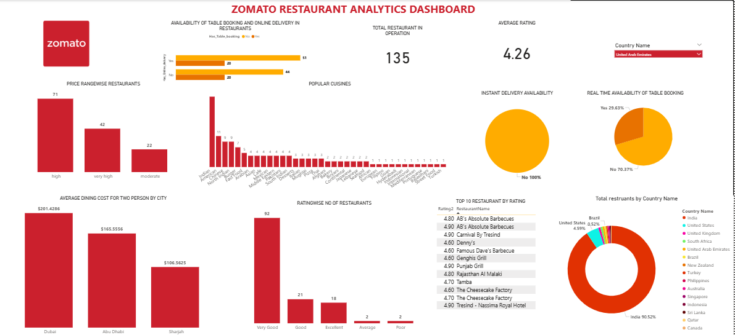**Actionable Insights**

**1. Instant Delivery Still Missing**

**Observation**: 0% of restaurants offer instant delivery.  
 **Opportunity**: Utilize high-traffic zones in Dubai/Abu Dhabi for rapid rollout of 20-minute delivery pilot kitchens.

### **2. Table Booking Integration Higher Than Average**

**Observation**: 29.63% of UAE restaurants offer real-time booking (vs 16.76% global).  
 **Improvement**: Expand API access and offer loyalty perks for full-table management onboarding.

### **3. Higher Restaurant Tech Adoption Rate**

**Observation**: 51 of 135 restaurants support either table booking, delivery, or both.  
 **Improvement**: UAE can serve as a testbed for “Zomato Digital Excellence” models to be exported to lower-digitized regions.

### **4. Premium Dining Dominates**

**Observation**: 113 out of 135 restaurants are in **high** or **very high** price brackets.  
 **Improvement**: Launch “Affordable Indulgence” segments, curated for expats and mid-income families.

### **5. Customer Satisfaction is High**

**Observation**: Average rating is 4.26, with most rated “Very Good” or “Excellent”.  
 **Improvement**: Package top-rated restaurant practices into a UAE Hospitality Playbook.

### **6. Dining Cost Still Moderate by UAE Standards**

**Observation**:

* **Dubai**: $201.43
* **Abu Dhabi**: $165.55
* **Sharjah**: $106.56  
   **Opportunity**: Introduce city-specific bundles (e.g., Dubai Brunch Pass, Sharjah Savers) to boost traffic in slower zones.

### **7. Cuisine Popularity Leans Indian and Middle Eastern**

**Observation**: Indian, Punjabi Grill, and Barbecue cuisine dominate.  
 **Improvement**: Run “Taste The World” campaigns during UAE’s festival season to diversify cuisine discovery.

### **8. Multiple Top Restaurants Rated 4.90**

**Insight**: Names like Tamba, Genghis Grill, and The Cheesecake Factory demonstrate service consistency.  
 **Improvement**: Launch “Zomato Star Series” spotlighting these names as benchmarks for others.

## **Strategic Improvements**

## **1. Activate Instant Delivery from Elite Zones**

Focus on Dubai Marina, Business Bay, Abu Dhabi Corniche with limited-menu delivery from select partners.

### **2. Strengthen Table Booking Ecosystem**

Offer tech-integration grants and POS training with Zomato APIs for full-service restaurants.

### **3. Use UAE as Digital Model Market**

Refine and document high-performing restaurant practices to apply in Saudi Arabia, Bahrain, and other GCC markets.

### **4. Normalize Premium with Value Tiers**

Introduce branded categories like “Lux on a Budget” and “Everyday Elite” to bridge premium and value segments.

### **5. Maintain High Service Ratings**

Offer certification programs for service, hygiene, and plating with visibility rewards.

### **6. Geo-Personalize Dining Offers**

Deliver time-limited, city-specific offers by population and affordability band.

### **7. Promote Cross-Cuisine Experimentation**

Reward users for trying new cuisines with “Discovery Points” and highlight regional chefs in editorial content.

### **8. Celebrate Consistent Top Performers**

Run “Zomato Gold Elite” recognition for restaurants that maintain >4.8 rating for over 6 months.

**Zomato Restaurant Analytics Dashboard – United Kingdom**

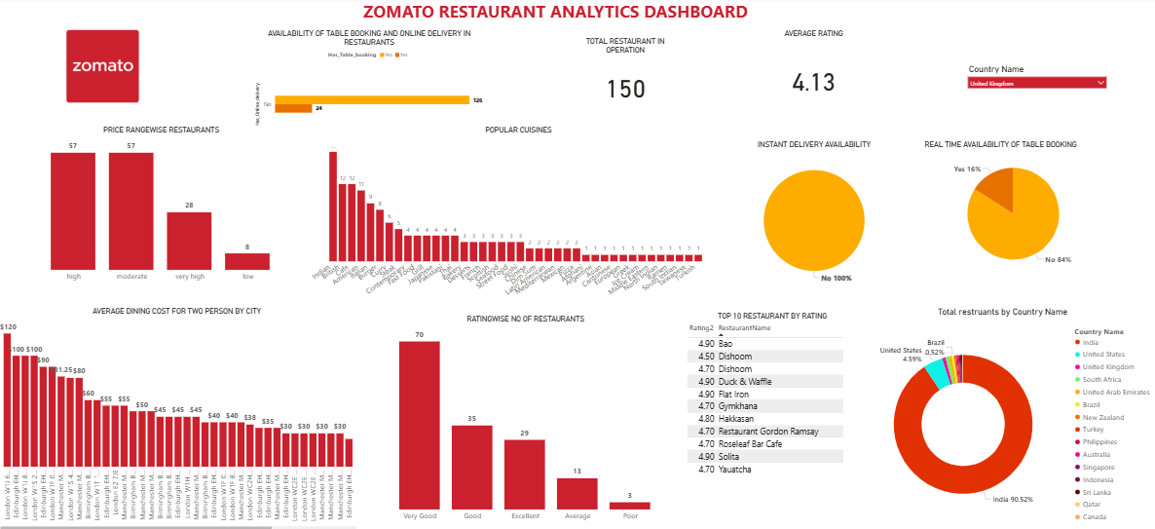**Actionable Insights**

1. **Instant Delivery Still Missing**
   1. **Observation**: 100% of restaurants do **not** offer instant delivery.
   2. **Opportunity**: Pilot instant delivery in zones like London, Manchester, and Birmingham with modular kitchens and express menus.
2. **Low Table Booking Integration**
   1. **Observation**: Only **16%** of restaurants support real-time bookings.
   2. **Improvement**: Encourage Zomato Pro-enabled real-time booking integrations with incentives for early adopters.
3. **Concentration in High & Moderate Price Categories**
   1. **Observation**: 57 restaurants each in High and Moderate brackets; Low category under-represented.
   2. **Improvement**: Explore value dining and fast-casual growth to expand affordability access.
4. **High Average Ratings**
   1. **Observation**: Average rating is **4.13**, better than most regions. 70 restaurants rated "Very Good".
   2. **Insight**: Strong service and food standards, but room for more Excellent-rated experiences.
   3. **Improvement**: Showcase “Excellence Journeys” from top-rated outlets to inspire others.
5. **Dining Cost is High in Some Areas**
   1. **Observation**: London leads with £120 average dining cost; Liverpool and Manchester also exceed £80.
   2. **Opportunity**: Create geo-targeted coupons and loyalty campaigns in high-cost zones.
6. **Cuisine Variety Centered on Local & Indian Influences**
   1. **Observation**: Top cuisines include Indian, American, and Contemporary British.
   2. **Improvement**: Introduce international spotlights on Asian, African, and Latin cuisines via seasonal features.
7. **Top Restaurants Feature Global Names**
   1. **Observation**: Gordon Ramsay, Dishoom, and Bao are among the top 10 with ratings of 4.50–4.90.
   2. **Improvement**: Highlight these names in “Zomato Culinary Legends” content for aspirational marketing.
8. **UK Makes Up a Small Fraction of Global Base**
   1. **Observation**: Only 0.92% of total Zomato restaurants are in the UK.
   2. **Strategic Priority**: Use London as a gateway to scale into other European markets.

### **Strategic Improvements for Zomato**

1. **Launch Cloud-Based Instant Delivery Programs**
   1. **Action**: Start with London and Birmingham.
   2. **Support**: Partner with virtual kitchen platforms and local logistics providers.
2. **Increase Real-Time Table Booking Adoption**
   1. **Action**: Simplify integration with POS platforms used in UK restaurants.
   2. **Incentive**: Feature “Book Now” restaurants on top of local search results.
3. **Balance the Price Mix**
   1. **Action**: Promote budget-friendly brands through categories like “Great Eats Under £40.”
   2. **Campaign**: Roll out “Everyday Bites” for casual diners.
4. **Optimize High-Rated Restaurant Learnings**
   1. **Action**: Build case studies and quality frameworks from restaurants rated 4.90.
   2. **Program**: Offer digital certification for hygiene and service excellence.
5. **Target High-Cost Cities with Value Offers**
   1. **Action**: Use city-level pricing data to run cashback offers, family dining discounts.
   2. **Tool**: Introduce in-app dining wallets for spend tracking and rewards.
6. **Champion Culinary Diversity**
   1. **Action**: Run “London Global Food Week,” sponsored food challenges, and influencer chef series.
   2. **Incentive**: Provide sponsored visibility to diverse cuisine restaurants.
7. **Expand Market Share in the UK**
   1. **Action**: Focus on high-density boroughs and commuter towns.
   2. **Approach**: Partner with tourism boards and hotel chains to boost Zomato adoption.

**Zomato Restaurant Analytics Dashboard – United States**

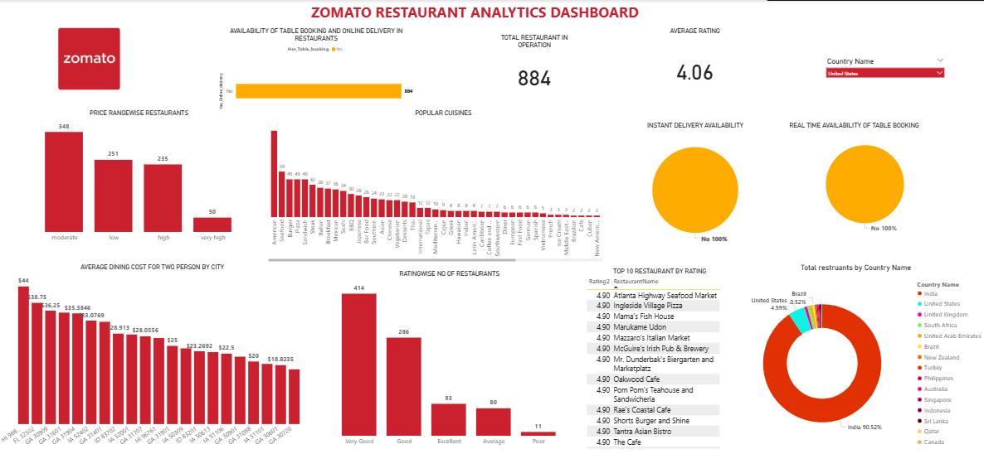**Actionable Insights**

1. **Instant Delivery Availability Absent**
   1. **Observation**: 100% of restaurants do not offer instant delivery.
   2. **Opportunity**: Launch instant delivery pilots in metro hubs like New York, LA, and Chicago with cloud kitchens and express menus.
2. **No Real-Time Table Booking Support**
   1. **Observation**: 0% of restaurants offer real-time table bookings.
   2. **Improvement**: Target U.S. chains and independent fine-dine restaurants to adopt booking systems through Zomato Pro plugins or POS integrations.
3. **Price Range Skews Moderate to Low**
   1. **Observation**: 348 moderate, 251 low-priced restaurants dominate the market.
   2. **Improvement**: Introduce "Premium Dining" experiences with chef-curated events and experiential add-ons (e.g., wine pairings, live music).
4. **Average Ratings Are Mid-High**
   1. **Observation**: Overall average rating is **4.06**, but only **80 rated Excellent**; **93 restaurants are Average**, and **11 rated Poor**.
   2. **Improvement**: Launch a U.S.-focused “Zomato Quality League” with hygiene audits and customer experience training.
5. **Dining Costs Are Reasonable Across Cities**
   1. **Observation**: Highest average cost is $44 (Grand Rapids), lowest is $18.82 (Orlando).
   2. **Opportunity**: Introduce flexible meal plans and dynamic pricing based on local affordability indexes.
6. **Strong Diversity in Cuisines**
   1. **Observation**: Popular cuisines include American, Seafood, Steak, and Italian — wide variety with 50+ types.
   2. **Improvement**: Enhance discovery of niche cuisines through themed events (e.g., “Global Taste Weeks”).
7. **Top Restaurants Score 4.90**
   1. **Observation**: Multiple top performers like Atlanta Highway Seafood Market and Mama’s Fish House consistently rate 4.90.
   2. **Improvement**: Use them in masterclass campaigns to educate mid-tier restaurants on operational excellence.
8. **Market Size is Small but Strategic**
   1. **Observation**: Only **4.59%** of Zomato’s total restaurants are in the U.S.
   2. **Strategic Priority**: Use high-income urban clusters for targeted expansion with premium delivery, chef partnerships, and Zomato Gold exclusives.

### **Strategic Improvements for Zomato**

1. **Launch Instant Delivery in Urban Centers**
   1. **Action**: Introduce 20-min express delivery with optimized cloud kitchens in New York, Chicago, LA.
   2. **Approach**: Partner with micro-fulfillment providers and limited-menu fast-prep concepts.
2. **Accelerate Booking System Adoption**
   1. **Action**: Provide ready-to-integrate APIs for online bookings.
   2. **Incentive**: Promote “Reserve with Zomato” badge and offer early-adopter promotions.
3. **Elevate Mid-Tier Ratings**
   1. **Action**: Host workshops on service training, cleanliness, and menu optimization.
   2. **Support**: Run monthly health check-ins for restaurants below 4.0 ratings.
4. **Strengthen Premium Dining Ecosystem**
   1. **Action**: Highlight upscale restaurants with verified reviews and photo stories.
   2. **Campaigns**: “Fine Dining Week,” “Wine & Dine” events, and “Luxury Bites” listings.
5. **Enhance Regional Offers via Pricing Insights**
   1. **Action**: Geo-segment promotions — e.g., weekday discounts in high-cost cities like Grand Rapids and Dallas.
   2. **Tools**: Enable dynamic pricing offers based on time and city.
6. **Promote Diverse Cuisines**
   1. **Action**: Run “Cultural Cuisine Festivals” on the platform featuring Greek, Japanese, Ethiopian cuisines.
   2. **Support**: Feature chef interviews and recipe spotlights.
7. **Leverage High-Rated Restaurants as Role Models**
   1. **Action**: Use top 10 outlets for training and showcase best practices via Zomato Academy U.S.
   2. **Mentorship**: Create a mentoring loop for low-rated restaurants.